Ex.No. 1

Date:

**DDL Commands – CREATE, ALTER, DROP**

**Aim:**

To Create, Alter and Drop the table using Data Definition Language.

1) Create a table name STUDENT with following structure.

|  |  |  |  |  |
| --- | --- | --- | --- | --- |
|  | Column |  |  |  |
| # | Name | ……………………………0 | Data Type |  |
|  |  |  |
|  |  | Registration |  |  |
| 1 | RegNo | Number | NUMBER(3) |  |
| 2 | Name | Student Name | VARCHAR(15) |  |
|  |  | Gender of the |  |  |
| 3 | Gender | student | CHAR(1) |  |
| 4 | DOB | Date of Birth | DATE |  |
| 5 | MobileNo | Mobile Number | NUMBER(10) |  |
| 6 | City | Location of stay | VARCHAR(15) |  |

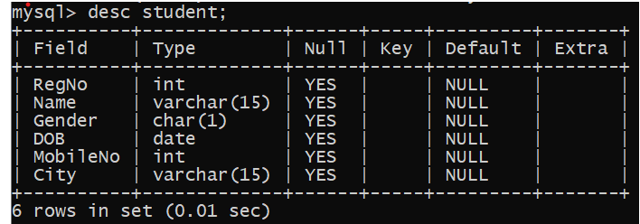

2.Create a table name FACULTY with following structure.

|  |  |  |  |  |
| --- | --- | --- | --- | --- |
|  | Column |  |  |  |
| # | Name | Description | Data Type |  |
|  |  |  |
| 1 | FacNo | Faculty Identifier | VARCHAR(4) |  |
| 2 | FacName | Faculty Name | VARCHAR(15) |  |
| 3 | Gender | Gender of faculty | CHAR(1) |  |
| 4 | DOB | Date of Birth | DATE |  |
| 5 | DOJ | Date of Join | DATE |  |
| 6 | MobileNo | Mobile Number | NUMBER(10) |  |

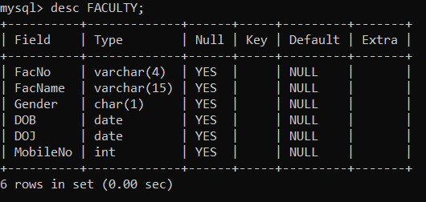

3.Create a table name DEPARTMENT with following structure.

|  |  |  |  |  |
| --- | --- | --- | --- | --- |
|  | Column |  |  |  |
| # | Name | Description | Data Type |  |
|  |  |  |
| 1 | DeptNo | Department Identifier | VARCHAR(4) |  |
| 2 | DeptName | Department Name | VARCHAR(15) |  |
| 3 | DeptHead | Department Head | VARCHAR(4) |  |
|  |  |  |  |  |
|  |  |  |  |  |

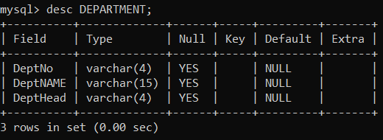

4.Create a table name COURSE with following structure.

|  |  |  |  |  |
| --- | --- | --- | --- | --- |
|  | Column |  |  |  |
| # | Name | Description | Data Type |  |
|  |  |  |
| 1 | CourseNo | Course Identifier | VARCHAR(3) |  |
|  |  | Course |  |  |
| 2 | CourseDesc | Description | VARCHAR(14) |  |
| 3 | CourseType | Course Type | CHAR(1) |  |
| 4 | SemNo | Semester Number | CHAR(1) |  |
| 5 | HallNo | Hall Number | VARCHAR(4) |  |
| 6 | FacNo | Faculty Identifier | VARCHAR(4) |  |
|  |  |  |  |  |
|  |  |  |  |  |
|  |  |  |  |  |

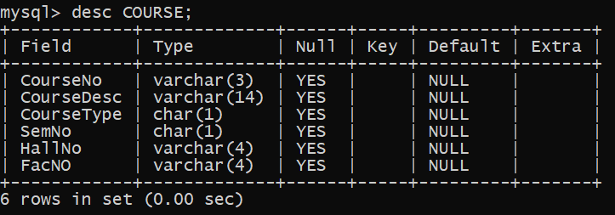

1. Modify the table FACULTY by adding a column name DeptNo of datatype VARCHAR(4)

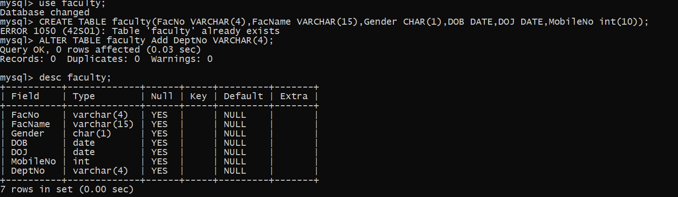

**RESULT:**

Tables are created, altered and modified using DDL commands.

Ex.No. 2

Date:

**DDL Commands with Constraints – PRIMARY, FOREIGN KEY, UNIQUE, CHECK**

**AIM:**

To add the constraints like primary key, foreign key, unique key and check using DDL commands.

1) Alter the table STUDENT with following structure.

|  |  |  |
| --- | --- | --- |
|  | Column | Constraints |
| # | Name |  |
|  |  | PRIMARY |
| 1 | RegNo | KEY |
| 2 | MobileNo | NOT NULL |

